COMMON COURSE ASSIGNMENT
CSA08 – GENERATIVE AI & PROMPT ENGINEERING | Covering Large Language Models & Prompt-Driven Engineering Assistance

A. Assignment Information
Department | Computer Science and Engineering
Programme | B.E. / B.Tech – CSE
Course Code & Course Name | CSA08 – Generative AI and Prompt Engineering
Academic Year / Batch | 2026 – 2027
Faculty Name | Dr.Chandravathi C
Assignment Title | Design and Implementation of PromptCraft – A Prompt-Driven Engineering Assistant using Large Language Models and Prompt Engineering
Date of Issue
Date of Submission
Maximum Marks | 100
Course Outcome(s) – CO | CO1 & CO2
Bloom's Taxonomy Level | L3 – Apply, L4 – Analyze, L5 – Evaluate
SDG Mapping (SDG 1–17) | SDG 4 – Quality Education; SDG 9 – Industry, Innovation and Infrastructure
Industry / Societal Relevance | Prompt-driven AI assistants are increasingly used across the software industry to accelerate coding, debugging, documentation, and requirement analysis, making skills in large language models and prompt engineering directly relevant to modern engineering practice.

B. Assignment Problem / Challenge
This assignment requires students to design, implement, and evaluate an AI-powered engineering assistant that applies core Generative AI concepts — prompt design and engineering techniques (zero-shot, few-shot, and chain-of-thought prompting), large language model (LLM) API integration, and structured evaluation of model outputs — to a unified engineering-support platform called Prompt Craft. Students must integrate multiple prompting strategies, build task-specific engineering modules, deploy the system as a lightweight web application, validate output quality and reliability with sample test cases, and address basic responsible-AI considerations such as transparency of prompts, hallucination handling, and reproducibility of results.

C. Problem Statement
Scenario: “PromptCraft” – A Prompt-Driven Engineering Assistant
Many students and practicing engineers find it difficult to consistently get high-quality, reliable outputs from large language models without structured prompting. Your task is to design and implement an interactive engineering-support web application called PromptCraft that helps engineers construct effective prompts, apply prompt engineering techniques, and use an LLM to accelerate common software-engineering tasks through a unified interface.
The system shall integrate three major functional modules:

1. Prompt Engineering Workbench
Implement zero-shot, few-shot, and chain-of-thought prompting templates for common engineering tasks.
- Users should be able to enter a task description, select a prompting strategy, and optionally supply few-shot examples or context.
- The system must display the fully constructed prompt sent to the LLM together with the generated response, enabling students to see exactly how prompt structure affects output quality.

2. LLM-Powered Engineering Task Modules
Implement at least three engineering-assistant task modules, e.g., code generation & explanation, automated debugging assistance, and requirement-to-documentation generation.
- Users will enter their engineering artifact (a code snippet, an error/bug description, or a requirement statement) as input to the selected module.
- The system should show the underlying prompt template used for each module, the LLM output, and any post-processing applied, so that students can trace how the assistant arrived at its result.

3. Prompt Strategy Evaluation & Comparison
Implement comparison of at least three prompting strategies (e.g., zero-shot, few-shot, chain-of-thought) for the same task.
- Users will enter a representative engineering task and a set of reference/expected outputs for evaluation.
- The system should display response quality, response time / latency, and token usage for each strategy, allowing clear comparative analysis.
Design the application workflow so that user inputs (task descriptions, code snippets, bug reports, requirement statements) are processed through the corresponding prompt templates and LLM calls, and the results are presented as clear prompts, responses, and comparative metrics. Develop a clean, simple web interface using Streamlit. Provide 2–3 sample test cases for each module to demonstrate effectiveness. Students must use a real or simulated LLM API (e.g., OpenAI, Anthropic, or an open-source model) to generate responses.
Evaluate the application under suitable test cases and analyze the quality of LLM outputs, usability of the interface, and clarity of the prompt/response traces. The completed system should also briefly address responsible-AI considerations including transparency of prompts, hallucination and error handling, data privacy, and reproducibility of results.

D. Requirements and Constraints
- Functional: Provide interactive modules for a Prompt Engineering Workbench (with visible prompt construction and response display), LLM-Powered Engineering Task Modules (code generation, debugging assistance, and documentation generation), and Prompt Strategy Evaluation (quality, latency, and token-usage comparison). Accept user inputs as well as sample data. Produce comparative tables and prompt/response traces.
- Interface: Clean, simple, and user-friendly Streamlit web application with separate pages or clearly separated sections for each module.
- Performance: LLM calls must return results with acceptable latency for interactive classroom use and support clear comparative analysis across prompting strategies.
- Technical constraint: Use Python + Streamlit. No database or complex architecture required. Use any accessible LLM API or open-source model for prompt execution.
- Reliability: Prompt templates and task modules must behave consistently and reproducibly; intermediate prompts must be transparent; the system must handle malformed inputs and LLM API errors without crashing.
- Resource constraint: Project must be completable within the semester timeline using standard student computing resources.
- Responsible Computing: Ensure transparency of prompts and model limitations, reproducibility of results, mitigation of hallucinated or misleading outputs, and adherence to responsible-AI and data-privacy practices.
- Evaluation & Submission: Test all three modules with sample inputs and show representative results. Submit working Streamlit code, a short report containing sample prompts/outputs / screenshots, comparative analysis, and a GitHub repository link.

E.Student Work
  - Problem Understanding and Formulation
Clearly restate the CampusConnect problem in your own words. Identify:
    - The specific synchronization, memory, and file-system challenges implied by the scenario.
    - Expected outcomes (deadlock-free concurrent access, efficient memory utilization, fast and fair disk access).
    - Assumptions you make (e.g., number of processes, page/frame sizes, file-size distribution) — state and justify all assumed values.
    - Constraints from Section D that must be satisfied by your design.
  - Application of Course Knowledge (CO2, CO3, CO4)
Answer the following three parts, showing all working, models, and derivations.
Part I – Process Synchronization & Deadlock (CO2, Unit II)
- Model the shared-file read/write access problem as a classical synchronization problem (e.g., Readers–Writers or Producer–Consumer). Write pseudocode using semaphores (or monitors) that correctly synchronizes access and avoids race conditions.
- Given 4 processes (P1–P4) contending for 4 resource types (a database handle, a print spooler, a network socket, and a file lock) with a stated allocation and request matrix (you may construct a reasonable example), apply the Banker's Algorithm to determine whether the system is in a safe state. Show the Safety Algorithm steps and identify a safe sequence, if one exists.
- Discuss which deadlock-handling strategy (Prevention, Avoidance, Detection & Recovery) is most suitable for CampusConnect and justify your choice with reference to the resource and reliability constraints in Section D.
- Given a physical memory of 8 GB with a page size of 4 KB, calculate the number of frames available. For a representative process requiring a logical address space of 64 MB, compute the number of pages and design its page table structure.
- For a reference string of at least 12 page references of your own construction (representative of a user session's memory access pattern), compare the number of page faults produced by FIFO, LRU, and Optimal page-replacement algorithms for a fixed number of frames (e.g., 3 or 4 frames). Present your results in a table.
- Explain how demand paging and the working-set model would help CampusConnect avoid thrashing when
300 concurrent sessions are active, and recommend a working-set size / frame-allocation policy with justification.
Part III – File Systems & Disk Scheduling (CO4, Unit IV)
- Compare Contiguous, Linked, and Indexed file allocation methods for CampusConnect's mixed file-size workload (small text files to multi-GB videos). Recommend the most suitable method with justification.
- Given a disk with 200 cylinders and a sequence of at least 8 pending I/O requests (you may construct a representative request queue) with the disk head starting at a stated cylinder, compute and compare the total head movement (seek time) for FCFS, SCAN, and C-SCAN disk-scheduling algorithms.
- Briefly relate your recommended allocation method and scheduling algorithm to Unix file-system concepts covered in the syllabus (e.g., inodes, buffer cache) and explain how they would be applied here.
  - Solution / Design / Methodology
Integrate your Part I–III analyses into a single consolidated OS resource-management design for CampusConnect. Present this as a design document containing:
    - A synchronization design (semaphore/monitor scheme + deadlock-handling strategy).
    - A memory-management design (paging scheme + page-replacement policy + working-set strategy).
    - A file-system and disk-scheduling design (allocation method + scheduling algorithm).
    - A simple architecture or flow diagram showing how these three subsystems interact when a user session accesses a shared file.
  - Use of Modern Tools
Implement and evidence your design using appropriate tools, for example:
    - Python / C: simulate the Banker's Algorithm, page-replacement algorithms, and disk-scheduling algorithms; include source code and console/output screenshots.
    - A Linux VM (or WSL): demonstrate semaphore-based synchronization using POSIX threads (pthreads) with a small working program and output screenshots.
    - Any OS simulator (e.g., OS process/deadlock simulators, disk-scheduling visualizers) may additionally be used to cross-verify manual calculations.
  - Results and Validation
    - Present page-fault counts (FIFO/LRU/Optimal) as a comparison table/graph.
    - Present total seek time/head movement (FCFS/SCAN/C-SCAN) as a comparison table/graph.
    - Present the Banker's Algorithm safety-check trace and program output.
    - Validate that your synchronization pseudocode/program produces no race conditions or deadlock under the stated resource constraints (Section D).
  - Analysis and Engineering Decision
    - Compare the page-replacement algorithms and justify which is best suited to CampusConnect's access pattern.

    - Compare the disk-scheduling algorithms and justify your final recommendation, considering fairness vs. average seek time.
    - Discuss the trade-offs of your chosen deadlock-handling strategy versus the alternatives (e.g., overhead of avoidance vs. risk under prevention).
    - Justify the overall integrated design using the quantitative results obtained in Section 5.
  - Broader Considerations
    - Reliability & Safety: How does your design ensure data integrity for shared academic files?
    - Sustainability/Economics: How does efficient memory and disk usage reduce hardware/energy costs for the university?
    - Accessibility & Society: How does the design ensure fair, responsive access for all concurrent users regardless of load?
    - Ethics/Professional responsibility: Considerations in handling student data and shared academic work.
  - Conclusion
Summarize your proposed synchronization, memory-management, and file-system/disk-scheduling design for CampusConnect. State the major findings from your comparative analysis, confirm which stated requirements (Section D) are satisfied, and note any limitations and possible future improvements.
  - Student Reflection
    - What did you learn from integrating synchronization, memory management, and file-system concepts together, beyond what was covered separately in class?
    - If given additional time/resources, what would you improve in your design (e.g., testing with a real workload, using a distributed file system), and why?
  - References
Cite all textbooks, datasets, standards, software/simulation tools, and any AI-assisted tools used, in a consistent citation format (e.g., IEEE).

CAMPUSCONNECT – OPERATING SYSTEMS RESOURCE MANAGEMENT DESIGN

1. Problem Understanding and Formulation

1.1 Problem Understanding
CampusConnect is a university-oriented digital platform that allows a large number of students, faculty members, and administrators to access academic resources simultaneously. The system may contain shared files such as lecture notes, assignments, project documents, examination materials, images, and large multimedia files. Since many users may access these resources at the same time, the operating system must efficiently manage processes, memory, files, and disk I/O.
The major challenge is to design an operating-system resource-management solution that supports safe concurrent access, efficient memory utilization, and fast and fair disk access.
Three major areas are considered in this design:
- Process Synchronization and Deadlock Management
- Memory Management
- File Systems and Disk Scheduling
For shared academic files, multiple users may read the same file simultaneously, while write operations must be protected from concurrent modifications. Therefore, synchronization mechanisms are required to prevent race conditions and maintain file consistency.
The system must also manage physical memory efficiently when hundreds of user sessions are active simultaneously. Paging, page replacement, demand paging, and working-set concepts can be used to minimize memory wastage and prevent thrashing.
Finally, CampusConnect may generate many disk requests from concurrent users. An appropriate file-allocation method and disk-scheduling algorithm are therefore required to provide efficient storage and fair access.

1.2 Synchronization Challenges
The major synchronization challenges are:
- Multiple users reading the same file simultaneously.
- A writer modifying a file while another user is reading it.
- Multiple processes competing for database handles, file locks, network sockets, and other resources.
- Race conditions during simultaneous updates.
- Possibility of deadlock when processes hold one resource while waiting for another.
- Ensuring that no user is permanently denied access.

1.3 Memory Management Challenges
The memory-management challenges include:
- 300 concurrent user sessions may generate a large number of memory requests.
- Processes may require different amounts of memory.
- Frequently accessed pages should remain in memory.
- Inactive pages should not unnecessarily occupy frames.
- Excessive page faults can reduce system performance.
- Thrashing must be avoided when memory demand becomes high.

1.4 File-System Challenges
CampusConnect may store:
- Small text documents
- PDF files
- Images
- Assignments
- Source-code files
- Large videos
- Multi-GB multimedia resources
Therefore, the selected allocation technique should support both small and very large files efficiently.

1.5 Expected Outcomes
The proposed design should achieve:
- Deadlock-free or safely controlled resource allocation.
- Race-free shared-file access.
- Efficient memory utilization.
- Reduced page faults.
- Prevention of thrashing.
- Efficient disk-head movement.
- Fair disk access for concurrent users.
- Reliable storage of academic files.
- Protection against inconsistent file updates.

1.6 Assumptions
Parameter | Assumed Value | Justification
Concurrent sessions | 300 | Given in the problem
Physical memory | 8 GB | Given
Page size | 4 KB | Given
Representative process address space | 64 MB | Given
Disk cylinders | 200 | Given
Disk cylinder numbering | 0–199 | Standard representation
Number of processes for Banker’s Algorithm | 4 | Given
Resource types | 4 | Given
Page-replacement frames | 3 | Suitable for comparison
Disk requests | 8 | Minimum requirement is 8
Files | Small text files to multi-GB videos | Given workload description

1.7 Constraints
The design must:
- Support concurrent access.
- Avoid race conditions.
- Handle deadlock safely.
- Use memory efficiently.
- Prevent excessive page faults and thrashing.
- Support mixed-size files.
- Provide efficient disk scheduling.
- Maintain fairness.
- Preserve academic-file integrity.
- Be implementable using standard computing resources.
- Provide simulations and evidence using Python/C and Linux/WSL where applicable.

2. Application of Course Knowledge

Part I – Process Synchronization and Deadlock

2.1 Shared-File Problem as Readers-Writers Problem
The shared-file access problem in CampusConnect can be modeled as the Readers-Writers synchronization problem.
Multiple readers can safely access a file simultaneously because reading does not modify the data. However, a writer must have exclusive access because simultaneous reading/writing or writing/writing can produce inconsistent data.

Synchronization Requirements
The system should satisfy:
- Multiple readers can read simultaneously.
- Only one writer can access the file at a time.
- Readers cannot access the file while a writer is modifying it.
- Race conditions must be avoided.
- Starvation should preferably be avoided.

Semaphores
We define:
rw_mutex = 1
mutex = 1
read_count = 0
Where:
- rw_mutex controls access to the shared file.
- mutex protects the read_count variable.
- read_count stores the number of active readers.

Reader Pseudocode
Reader()

wait(mutex)
read_count = read_count + 1

if read_count == 1:
wait(rw_mutex)

signal(mutex)

READ shared file

wait(mutex)
read_count = read_count - 1

if read_count == 0:
signal(rw_mutex)

signal(mutex)

Writer Pseudocode
Writer()

wait(rw_mutex)

WRITE shared file

signal(rw_mutex)

Explanation
When the first reader enters, it acquires rw_mutex. Other readers can then read simultaneously. When the last reader leaves, it releases rw_mutex.
A writer must obtain rw_mutex before writing. Therefore, readers and writers cannot simultaneously modify or access the shared file in an unsafe manner.
For a production implementation, a fair reader-writer lock or monitor can additionally be used to prevent writer starvation.

2.2 Banker's Algorithm
Four processes compete for four resource types:
- D = Database Handle
- P = Print Spooler
- N = Network Socket
- F = File Lock
Assume there are 2 instances of each resource.

Allocation Matrix
Process | D | P | N | F
P1 | 1 | 0 | 0 | 1
P2 | 0 | 1 | 1 | 0
P3 | 1 | 0 | 1 | 0
P4 | 0 | 0 | 0 | 1
Total allocation:
D = 2
P = 1
N = 2
F = 2
Assume the available resources are:
Available = [1, 1, 0, 0]
However, this would not permit the first process to complete under the chosen maximum matrix. To provide a clear safe-state demonstration, we assume the current available vector is:
Available = [1, 1, 1, 1]

Maximum Matrix
Process | D | P | N | F
P1 | 1 | 1 | 1 | 1
P2 | 1 | 1 | 1 | 1
P3 | 1 | 1 | 1 | 1
P4 | 1 | 1 | 1 | 1

Need Matrix
The formula is:
Need=Max−AllocationNeed = Max - Allocation
Therefore:
Process | D | P | N | F
P1 | 0 | 1 | 1 | 0
P2 | 1 | 0 | 0 | 1
P3 | 0 | 1 | 0 | 1
P4 | 1 | 1 | 1 | 0

2.3 Safety Algorithm
Initially:
Work = Available
= [1, 1, 1, 1]

Step 1 – Check P1
Need(P1) = [0,1,1,0]
Work = [1,1,1,1]
Since:
Need(P1) <= Work
P1 can finish.
After P1 finishes, it releases:
Allocation(P1) = [1,0,0,1]
Therefore:
Work = [1,1,1,1] + [1,0,0,1]
= [2,1,1,2]
Safe sequence:
P1

Step 2 – Check P2
Need(P2) = [1,0,0,1]
Work = [2,1,1,2]
P2 can finish.
Release:
Allocation(P2) = [0,1,1,0]
Therefore:
Work = [2,1,1,2] + [0,1,1,0]
= [2,2,2,2]
Safe sequence:
P1 → P2

Step 3 – Check P3
Need(P3) = [0,1,0,1]
Work = [2,2,2,2]
P3 can finish.
Release:
Allocation(P3) = [1,0,1,0]
Therefore:
Work = [2,2,2,2] + [1,0,1,0]
= [3,2,3,2]
Safe sequence:
P1 → P2 → P3

Step 4 – Check P4
Need(P4) = [1,1,1,0]
Work = [3,2,3,2]
P4 can finish.
Release:
Allocation(P4) = [0,0,0,1]
Therefore:
Work = [3,2,3,2] + [0,0,0,1]
= [3,2,3,3]

Final Result
Safe Sequence = P1 → P2 → P3 → P4
Therefore:
The system is in a SAFE state because all four processes can complete in the sequence P1 → P2 → P3 → P4.

2.4 Suitable Deadlock-Handling Strategy
Among the three major approaches:
- Deadlock Prevention
- Deadlock Avoidance
- Deadlock Detection and Recovery
Deadlock Avoidance using the Banker's Algorithm is selected for the CampusConnect resource-management model.

Reason
CampusConnect has several shared resources such as:
- Database handles
- File locks
- Network resources
- Printing resources
The Banker's Algorithm checks whether allocating resources will leave the system in a safe state.

Advantages
- Prevents the system from entering an unsafe state.
- Provides a systematic resource-allocation mechanism.
- Suitable for resources whose maximum requirements can be estimated.
- Provides predictable behavior.

Limitation
The algorithm introduces computational overhead because resource requests must be evaluated.

Comparison
Strategy | Advantage | Disadvantage
Prevention | Simple concept | Can reduce resource utilization
Avoidance | Prevents unsafe states | Requires maximum resource information
Detection & Recovery | Flexible resource allocation | Deadlock can occur before detection
For the academic resource-management model, avoidance is preferred because reliability and predictable behavior are important.

Part II – Memory Management

2.5 Number of Physical Frames
Given:
Physical memory = 8 GB
Page size = 4 KB
Convert 8 GB:
8GB=8×1024×1024KB8GB = 8 \times 1024 \times 1024 KB =8,388,608KB= 8,388,608 KB
Number of frames:
Frames=8,388,6084Frames = \frac{8,388,608}{4} =2,097,152= 2,097,152
Therefore:
Number of physical frames = 2,097,152 frames.

2.6 Number of Pages for 64 MB Process
Given:
Logical address space = 64 MB
Page size = 4 KB
Convert:
64MB=64×1024KB64MB = 64 \times 1024KB =65,536KB=65,536KB
Therefore:
Pages=65,5364Pages = \frac{65,536}{4} =16,384=16,384
Therefore:
The process requires 16,384 pages.

2.7 Page Table Structure
The logical address can be divided into:
Page Number | Offset
Since:
4KB=4096=2124KB = 4096 = 2^{12}
the offset requires 12 bits.
For a 64 MB address space:
64MB=22664MB = 2^{26}
Therefore logical addresses contain 26 bits.
Thus:
Logical Address
┌───────────────────┬──────────────┐
│ Page Number │ Offset │
│ 14 bits │ 12 bits │
└───────────────────┴──────────────┘
because:
26−12=1426-12=14
The page number can represent:
214=16,3842^{14}=16,384
pages.
Therefore, a single-level page table contains:
16,384 page-table entries.
A page-table entry can contain:
- Frame number
- Valid/invalid bit
- Protection bits
- Reference bit
- Dirty bit

2. Page Replacement Algorithms
For comparison, assume:
Number of frames = 3
Reference string:
1, 2, 3, 1, 4, 5, 2, 1, 2, 3, 4, 5
This represents a user session that repeatedly accesses some pages and later returns to previously accessed pages.

Page-Fault Comparison
Reference String | FIFO | LRU | Optimal
1 | F | F | F
2 | F | F | F
3 | F | F | F
1 | Hit | Hit | Hit
4 | F | F | F
5 | F | F | F
2 | F | F | F
1 | F | F | Hit
2 | Hit | Hit | Hit
3 | F | F | F
4 | F | F | Hit
5 | F | F | F
Total Faults | 10 | 10 | 7
Therefore:
FIFO = 10 page faults
LRU = 10 page faults
Optimal = 7 page faults

Interpretation
Optimal produces the lowest number of page faults because it has knowledge of future references.
However, Optimal cannot normally be implemented in a real operating system because the future reference string is unknown.
LRU is therefore generally more practical because it uses recent access history to approximate the behavior of Optimal.

2.9 Demand Paging and Working Set
CampusConnect may have 300 concurrent sessions. Loading every possible page of every process into memory would waste physical memory.

Demand Paging
With demand paging, pages are loaded into memory only when they are actually required.
Process:
CPU references page
↓
Is page in memory?
↙ ↘
YES NO
↓ ↓
Continue Page Fault
↓
Load page from disk
↓
Update page table
↓
Continue
This reduces unnecessary memory usage.

Working-Set Model
The working set is the group of pages actively used by a process during a particular time interval.
For example, assume:
Working-set size = 32 pages/session
For 300 sessions:
300×32=9600 pages300 \times 32 = 9600 \text{ pages}
Since each page is 4 KB:
9600×4KB=38,400KB9600 \times 4KB = 38,400KB
Approximately:
37.5MB37.5MB
Therefore, if the workload really has an average active working set of 32 pages per session, approximately 37.5 MB would be required for those active pages.

Recommended Policy
A dynamic working-set policy is recommended:
- Allocate approximately 32 frames initially per active session.
- Monitor page-fault frequency.
- Increase allocation for sessions showing sustained high locality.
- Reduce allocation for inactive sessions.
- Suspend or deprioritize inactive background tasks if memory pressure becomes high.
This prevents excessive page swapping and reduces the probability of thrashing.

Part III – File Systems and Disk Scheduling

2.10 File Allocation Methods
CampusConnect has a mixed workload ranging from small text files to multi-GB videos.
Feature | Contiguous | Linked | Indexed
Sequential access | Excellent | Good | Good
Random access | Excellent | Poor | Good
Fragmentation | External fragmentation | No external fragmentation | Low
Large files | Difficult to extend | Suitable | Suitable
Small files | Excellent | Good | Extra index overhead
Metadata overhead | Low | Moderate | Higher
File growth | Difficult | Easy | Easy
Reliability | Good | Pointer dependency | Good
Mixed workload | Moderate | Good | Very Good

Recommended Method
Indexed allocation is recommended for CampusConnect.
The reason is that the system contains both small files and very large files. Indexed allocation provides direct/random access while allowing files to grow without requiring a large contiguous region.
In Unix-like systems, inode-based structures provide a practical form of indexed addressing using direct and indirect block references.

2.11 Disk Scheduling
Assume:
Number of cylinders = 200
Cylinder range = 0–199
Initial head position = 53
Pending requests:
98, 183, 37, 122, 14, 65, 67, 190
Assume the SCAN and C-SCAN head initially move toward higher-numbered cylinders.

FCFS
Request order:
53 → 98 → 183 → 37 → 122 → 14 → 65 → 67 → 190
Head movement:
∣98−53∣=45|98-53|=45 ∣183−98∣=85|183-98|=85 ∣37−183∣=146|37-183|=146 ∣122−37∣=85|122-37|=85 ∣14−122∣=108|14-122|=108 ∣65−14∣=51|65-14|=51 ∣67−65∣=2|67-65|=2 ∣190−67∣=123|190-67|=123
Total:
45+85+146+85+108+51+2+12345+85+146+85+108+51+2+123 =645=\boxed{645}

FCFS Total Head Movement
645 cylinders

SCAN
Requests greater than 53:
65, 67, 98, 122, 183, 190
Requests lower than 53:
14, 37
SCAN moves upward first:
53 → 65 → 67 → 98 → 122 → 183 → 190 → 199
Then reverses:
199 → 37 → 14
Head movement:
199−53=146199-53=146
Then:
199−14=185199-14=185
Total:
146+185=331146+185=\boxed{331}

SCAN Total Head Movement
331 cylinders

C-SCAN
C-SCAN moves in one direction only.
Order:
53 → 65 → 67 → 98 → 122 → 183 → 190 → 199
Then it returns to:
0
and continues:
0 → 14 → 37
Head movement:
199−53=146199-53=146
Wraparound:
199−0=199199-0=199
Then:
37−0=3737-0=37
Total:
146+199+37146+199+37 =382=\boxed{382}

Final Comparison
Algorithm | Total Head Movement
FCFS | 645 cylinders
SCAN | 331 cylinders
C-SCAN | 382 cylinders

Observation
SCAN produces the lowest head movement for this particular request sequence.
FCFS has the highest movement because requests are served strictly in arrival order.
C-SCAN has slightly higher movement than SCAN in this example because it includes the circular return to the beginning.

2.12 Unix File-System Concepts
The recommended indexed allocation method can be related to Unix file-system concepts.

Inodes
A Unix inode stores metadata about a file, such as:
- File type
- Permissions
- Owner
- File size
- Timestamps
- References to data blocks
The block pointers allow the operating system to locate the file's contents.
For CampusConnect, a large video could use direct and indirect block references to locate its data blocks.

Buffer Cache
A buffer cache keeps frequently accessed disk blocks in memory.
For example, if many students access the same lecture PDF, its frequently used blocks can remain cached.
This reduces repeated disk access and improves response time.

Disk Scheduling
SCAN can be used to organize disk requests efficiently.
Therefore:
CampusConnect
↓
Indexed/Inode-based file organization
↓
Buffer Cache
↓
Disk Request Queue
↓
SCAN Scheduler
↓
Disk

3. Solution / Design / Methodology
The proposed CampusConnect resource-management architecture integrates synchronization, memory management, file management, and disk scheduling.

3.1 Integrated Architecture

┌──────────────────────┐
│ CampusConnect User │
│ Session │
└──────────┬───────────┘
│
▼
┌──────────────────────┐
│ Process Manager │
└──────────┬───────────┘
│
┌─────────────────┼──────────────────┐
│ │ │
▼ ▼ ▼
┌────────────────┐ ┌────────────────┐ ┌────────────────┐
│ Synchronization│ │ Memory Manager │ │ File System │
│ Manager │ │ │ │ Manager │
└───────┬────────┘ └───────┬────────┘ └───────┬────────┘
│ │ │
▼ ▼ ▼
Semaphores / Paging / LRU Indexed Files
RW Locks Working Set │
│ │ ▼
│ │ Inodes/Metadata
│ │ │
│ ▼ ▼
│ Physical RAM Buffer Cache
│ │
└─────────────────────────────────────┘
│
▼
┌────────────────────┐
│ Disk Request Queue │
└─────────┬──────────┘
│
▼
┌────────────────────┐
│ SCAN Scheduler │
└─────────┬──────────┘
│
▼
DISK

3.2 Synchronization Design
The synchronization subsystem uses:
- Readers-Writers synchronization.
- Semaphores.
- Reader counter.
- Exclusive writer lock.
For resource allocation, Banker's Algorithm can be used where maximum resource requirements are known.

Design Choice
Shared File
↓
Read request → Reader synchronization
↓
Multiple readers allowed

Write request
↓
Exclusive lock
↓
File modification
↓
Release lock

3.3 Memory Management Design
The proposed memory-management design uses:
- Demand paging
- 4 KB pages
- Page tables
- LRU page replacement
- Working-set monitoring

Reason for LRU
From the test:
FIFO = 10 faults
LRU = 10 faults
Optimal = 7 faults
Although Optimal performs best in the simulation, it requires knowledge of future references. LRU is therefore selected as the practical replacement policy.

3.4 File-System and Disk Design
Recommended configuration:
File Allocation → Indexed / inode-based
Cache → Buffer cache
Disk Scheduling → SCAN
SCAN is selected because it provides substantially lower head movement than FCFS for the representative workload while maintaining better fairness than simply servicing requests in arbitrary order.

4. Use of Modern Tools
The proposed design can be implemented and demonstrated using the following tools.
Tool | Application
Python | Algorithm simulation
C | Synchronization implementation
GCC | C compilation
Linux/WSL | POSIX thread demonstration
pthreads | Semaphore/thread synchronization
VS Code/IDLE | Program development
Matplotlib | Graph generation
GitHub | Source-code submission

4.1 Python Simulations
Python can be used to implement:
- Banker's Algorithm
- FIFO
- LRU
- Optimal
- FCFS
- SCAN
- C-SCAN
The programs should print:
Algorithm
Input
Step-by-step execution
Final result

4.2 POSIX Thread Demonstration
A C program using POSIX threads can demonstrate the Readers-Writers problem.
The program should create multiple reader and writer threads and use synchronization mechanisms to ensure that:
- Multiple readers can execute together.
- Writers execute exclusively.
- No race condition occurs.
- The program terminates without deadlock.

Suggested evidence screenshots
Include:
- C source code.
- Compilation command.
- Program execution.
- Reader output.
- Writer output.
- Successful termination.

5. Results and Validation

5.1 Page-Replacement Results
Algorithm | Page Faults
FIFO | 10
LRU | 10
Optimal | 7

Result
Optimal gives the lowest page-fault count.
However, because future references cannot normally be known, LRU is selected for practical implementation.

5.2 Disk Scheduling Results
Algorithm | Head Movement
FCFS | 645
SCAN | 331
C-SCAN | 382

Result
SCAN provides the lowest movement for the selected workload.
Compared with FCFS:
645−331=314645-331=314
SCAN reduces head movement by:
314645×100≈48.68%\frac{314}{645}\times100 \approx48.68\%
Thus, SCAN reduces the representative head movement by approximately 48.7% compared with FCFS.

5.3 Banker's Algorithm Result
Initial Work = [1,1,1,1]

P1 → Work = [2,1,1,2]
P2 → Work = [2,2,2,2]
P3 → Work = [3,2,3,2]
P4 → Work = [3,2,3,3]
Therefore:
System State = SAFE

Safe Sequence:
P1 → P2 → P3 → P4

5.4 Synchronization Validation
The synchronization design is validated using multiple reader and writer processes.
Expected behavior:
Reader 1 starts reading
Reader 2 starts reading
Reader 3 starts reading

Writer waits

Readers finish

Writer obtains exclusive access
Writer modifies file
Writer releases lock
This demonstrates that:
- Readers can share access.
- Writers receive exclusive access.
- Concurrent modification is prevented.
- Race conditions are avoided.

6. Analysis and Engineering Decision

6.1 Page Replacement Decision
The experimental result is:
FIFO = 10
LRU = 10
Optimal = 7
Optimal is theoretically the best because it knows future references. However, this information is not available to a real operating system.
LRU is therefore selected because it uses recent access history. Applications such as CampusConnect are expected to show locality because users repeatedly access recently viewed academic resources.

Final Choice
LRU is selected as the practical page-replacement algorithm.

6.2 Disk Scheduling Decision
The results are:
FCFS = 645
SCAN = 331
C-SCAN = 382
FCFS is simple but produces significantly higher head movement.
SCAN provides the lowest movement for the chosen workload and services requests in an organized direction.
C-SCAN provides more uniform waiting behavior because requests are serviced in a circular manner, but its wraparound increases movement.

Final Choice
SCAN is selected for the representative CampusConnect workload because it provides a strong balance between seek efficiency and fairness.

6.3 Deadlock Strategy Decision
Banker's Algorithm provides a safe-state check before resource allocation.

Avoidance
Advantages:
- Prevents unsafe allocations.
- Provides predictable behavior.
Disadvantages:
- Requires maximum resource information.
- Introduces computational overhead.

Prevention
Advantage: Simple guarantees against certain deadlock conditions.
Disadvantage: Can unnecessarily restrict resource utilization.

Detection and Recovery
Advantage: Resources can be allocated more freely.
Disadvantage: Deadlock is allowed to occur and must later be resolved.

Final Decision
Deadlock avoidance is preferred for the modeled CampusConnect resource environment because system reliability and predictable resource allocation are important.

6.4 Overall Engineering Decision
Subsystem | Selected Technique | Reason
Synchronization | Readers-Writers + Semaphores | Safe shared-file access
Deadlock | Banker's Algorithm | Safe-state resource allocation
Memory | Demand Paging | Efficient memory use
Page Replacement | LRU | Practical locality-based policy
Working Set | Dynamic allocation | Prevent thrashing
File Allocation | Indexed/inode-based | Supports mixed file sizes
Cache | Buffer Cache | Reduces disk accesses
Disk Scheduling | SCAN | Low head movement + fairness

7. Broader Considerations

7.1 Reliability and Safety
Data integrity is important because CampusConnect may contain:
- Student assignments
- Examination documents
- Academic records
- Faculty resources
- Project files
The synchronization mechanism prevents simultaneous conflicting writes.
The system can additionally use:
- File permissions
- Access control
- Atomic file updates
- Backup mechanisms
- Checksums
- Logging
These mechanisms help prevent accidental corruption.

7.2 Sustainability and Economics
Efficient memory and disk management can reduce unnecessary hardware utilization.
Demand paging prevents unnecessary pages from occupying memory.
Buffer caching reduces repeated disk operations.
Efficient disk scheduling reduces unnecessary head movement.
Therefore, the proposed design can help reduce:
- CPU waiting time
- Disk activity
- Energy consumption
- Hardware wear
- Unnecessary resource utilization
This can reduce the operating cost of university computing infrastructure.

7.3 Accessibility and Society
CampusConnect should provide fair access to all users.
The proposed design supports this by:
- Preventing indefinite resource blocking.
- Using fair synchronization policies.
- Reducing disk waiting time.
- Dynamically managing memory.
- Prioritizing active sessions appropriately.
- Avoiding starvation where possible.
This is especially important during high-demand periods such as:
- Examination registration
- Assignment submission
- Results publication
- Online examinations

7.4 Ethics and Professional Responsibility
Student information and academic work must be protected.
The system should:
- Avoid unauthorized file access.
- Protect personal information.
- Apply appropriate permissions.
- Avoid exposing private academic documents.
- Maintain audit logs for sensitive operations.
- Provide reliable backups.
- Ensure that administrators access data only when authorized.
Professional responsibility also requires testing the system before deployment and communicating known limitations.
Graphs
- Page Replacement Algorithms – Page Fault Comparison
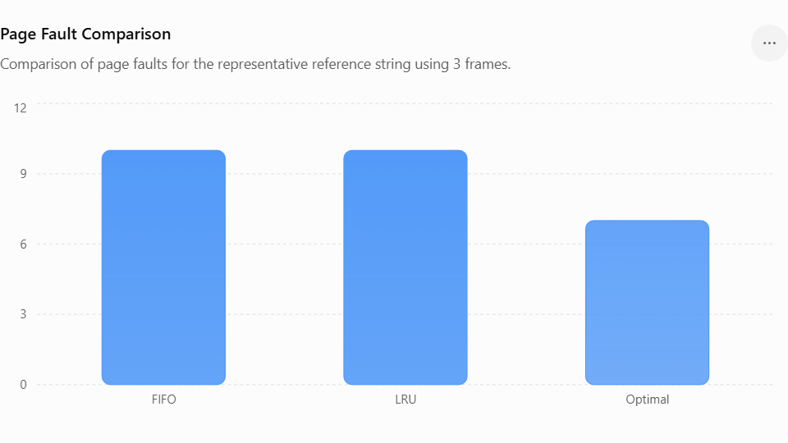
Fig.1
2. Disk Scheduling – Head Movement Comparison
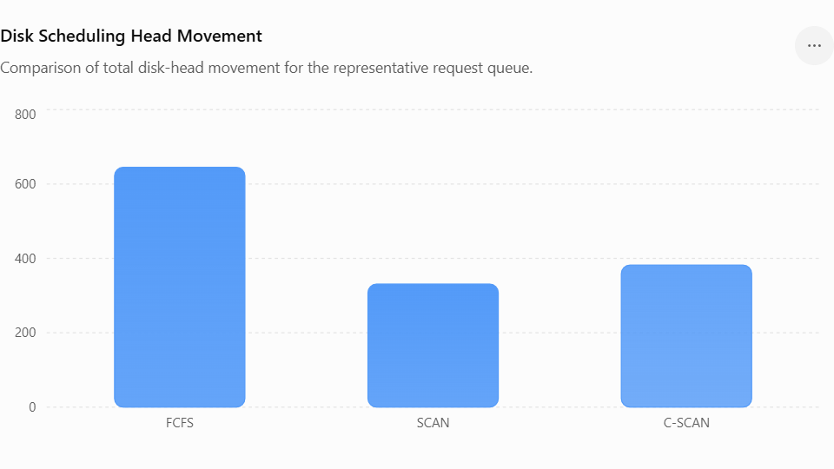
Figure 2: Comparison of total disk-head movement for FCFS, SCAN, and C-SCAN algorithms.

8. Conclusion
The CampusConnect resource-management design integrates process synchronization, deadlock management, memory management, file systems, and disk scheduling into a single operating-system design.
The Readers-Writers model with semaphores provides safe concurrent access to shared academic files. Banker's Algorithm was applied to four processes and four resource types, resulting in the safe sequence:
P1→P2→P3→P4\boxed{P1 \rightarrow P2 \rightarrow P3 \rightarrow P4}
For memory management, an 8 GB physical memory with 4 KB pages provides:
2,097,152 frames\boxed{2,097,152\text{ frames}}
A 64 MB process requires:
16,384 pages\boxed{16,384\text{ pages}}
The page-replacement experiment produced:
Algorithm | Faults
FIFO | 10
LRU | 10
Optimal | 7
Although Optimal gives the lowest number of faults, LRU is selected for practical use because future page references are unavailable.
For disk scheduling:
Algorithm | Head Movement
FCFS | 645
SCAN | 331
C-SCAN | 382
SCAN provides approximately 48.7% lower head movement than FCFS for the representative request sequence.
The final integrated design therefore recommends:
Readers-Writers synchronization + Banker's Algorithm + Demand Paging + LRU + Working-Set Management + Indexed/Inode-Based File Allocation + Buffer Cache + SCAN Disk Scheduling.
The design satisfies the major requirements of safe concurrent access, efficient memory management, reliable file storage, and efficient disk access.
The major limitation is that the numerical results are based on representative assumptions and synthetic workloads. A real CampusConnect implementation would require measurements using actual university workloads.

9. Student Reflection
This project helped me understand that operating-system concepts cannot always be considered independently. Process synchronization, memory management, and file-system management are closely connected when designing a real-world multi-user application such as CampusConnect.
While studying synchronization separately, I understood how semaphores and the Readers-Writers problem prevent race conditions. However, integrating synchronization with file-system access helped me understand why proper locking is essential when multiple users access shared academic files simultaneously.
The Banker's Algorithm helped me understand how an operating system can determine whether resource allocation will result in a safe or unsafe state. The practical example with four processes and four resource types made the safety algorithm easier to understand.
The memory-management analysis demonstrated the importance of paging and page replacement. The comparison of FIFO, LRU, and Optimal showed that theoretical optimal performance is not always directly achievable in real systems because future page references are unknown.
The disk-scheduling experiment also showed how the order of disk requests can significantly affect performance. The comparison between FCFS, SCAN, and C-SCAN demonstrated the trade-off between simplicity, seek efficiency, and fairness.
If additional time and resources were available, I would test the design using a real university workload containing actual patterns of student file access. I would also implement the system on a Linux server and measure memory utilization, page-fault frequency, disk response time, and synchronization overhead under hundreds or thousands of concurrent users.
A future version could use a distributed file system for large multimedia resources and could introduce more advanced scheduling and caching techniques.
Implementation/output
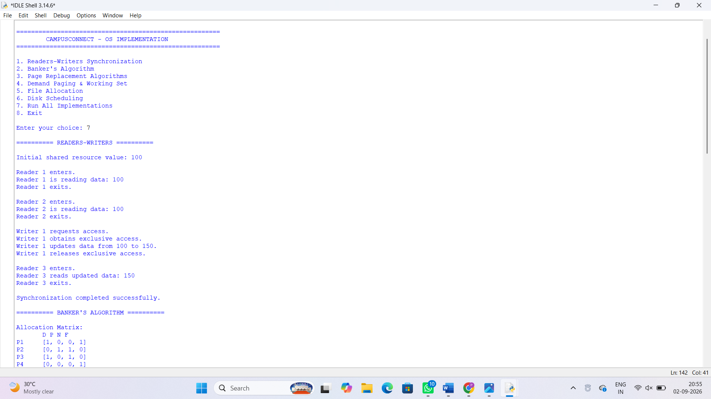
Fig.3
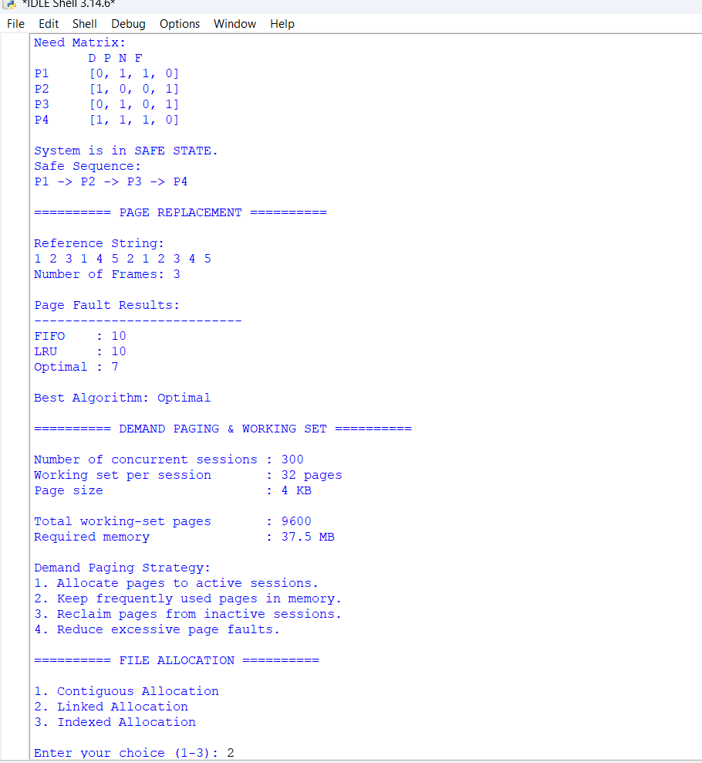
Fig.4
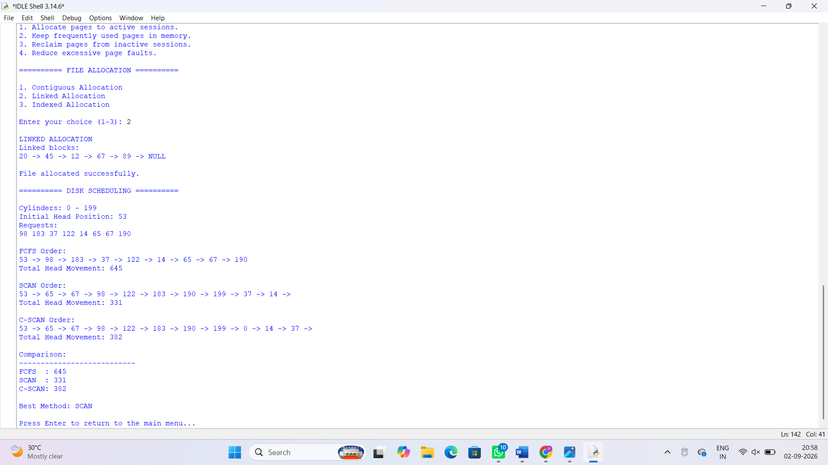
Fig.5

Implementation Code
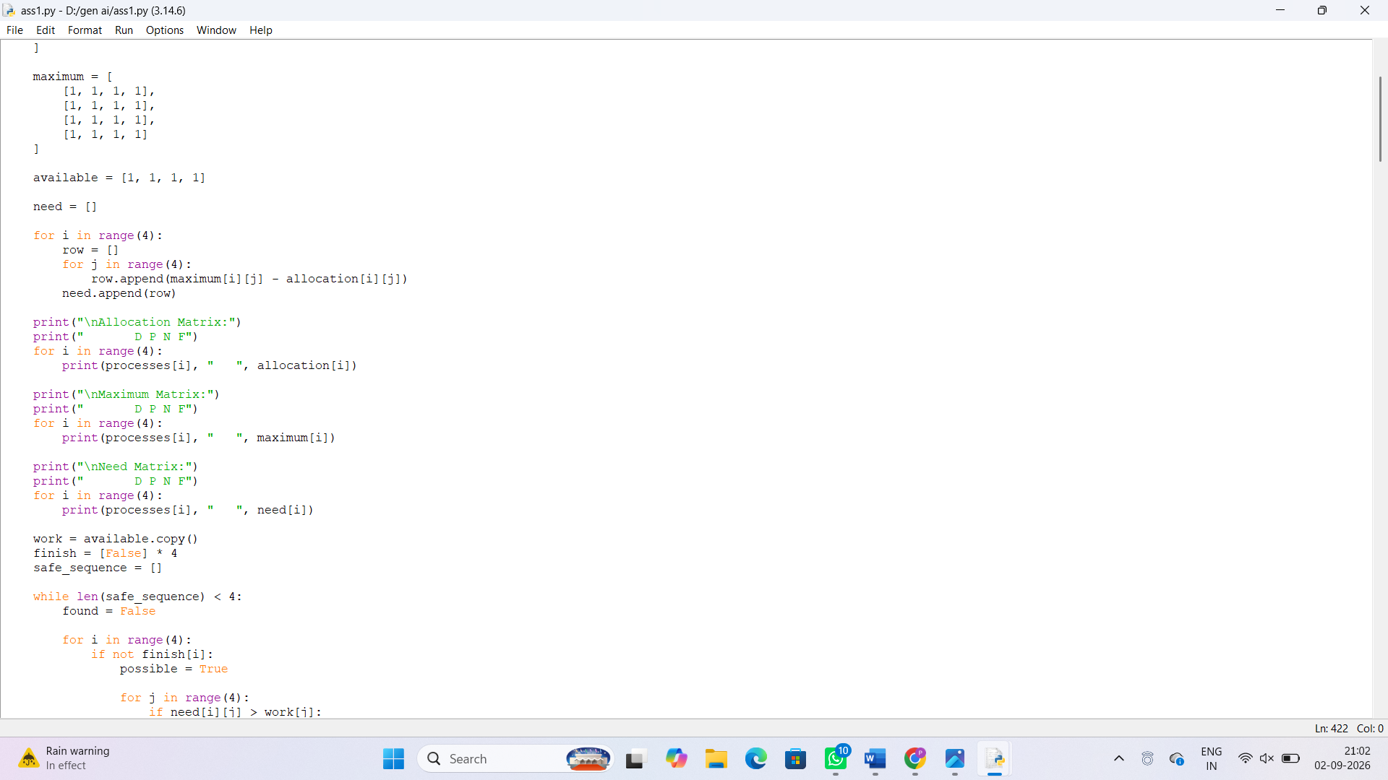

Fig.6

10. References
Use the following IEEE-style references in your report.
1.A. Silberschatz, P. B. Galvin, and G. Gagne, Operating System Concepts, 10th ed. Hoboken, NJ, USA: Wiley, 2018.
2. W. Stallings, Operating Systems: Internals and Design Principles, 9th ed. Pearson, 2018.
3.A. S. Tanenbaum and H. Bos, Modern Operating Systems, 4th ed. Pearson, 2015.
4.M. Kifer, F. A. Neumann, and A. Bernstein, Operating Systems: Principles and Practice. CreateSpace, 2011.
5. Python Software Foundation, Python 3 Documentation. Python Software Foundation.
6. Free Software Foundation, The GNU C Library Reference Manual. Free Software Foundation.
7.The Linux Kernel Organization, The Linux Kernel Documentation. Linux Kernel Organization.
8.IEEE, IEEE Standard for Information Technology—Portable Operating System Interface (POSIX).
9.GitHub, GitHub Documentation, GitHub.
10. OpenAI, ChatGPT, AI-assisted tool used for explanation, drafting, and assistance during report preparation.

F. Common Assessment Rubric
Assessment Criterion | Marks
Problem understanding & formulation | 10
Application of course / domain knowledge (Prompt Engineering, LLM Integration, Evaluation) | 20
Solution methodology / design / implementation | 20
Use of appropriate modern tools / techniques (Python, LLM APIs, Prompt Engineering Frameworks) | 10
Results, testing & validation | 15
Analysis, trade-offs & justification | 15
Broader considerations / professional responsibility | 5
Technical documentation & reflection | 5
TOTAL | 100

G. CO–PO–Assessment Mapping
Assessment Component | CO | PO(s) | Bloom's Level | Marks
Problem formulation | CO1/CO2 | PO1, PO2 | L3 | 10
Application – Prompt Engineering Techniques | CO1/CO2 | PO1, PO2, PO3 | L3/L4 | 8
Application – LLM Task Module Integration | CO1 | PO1, PO2, PO3 | L3/L4 | 6
Application – Evaluation & Comparison of Prompts | CO2 | PO1, PO2, PO3 | L3/L4 | 6
Solution / Design – Integrated PromptCraft | CO1–CO2 | PO2, PO3, PO5 | L4/L5/L6 | 20
Modern tool usage (Python, LLM APIs, Prompt Engineering) | CO1–CO2 | PO5 | L3 | 10
Validation of results | CO1–CO2 | PO4 | L4/L5 | 15
Analysis & justification / trade-offs | CO1–CO2 | PO2, PO4 | L4/L5 | 15
Broader considerations & documentation / reflection | CO1–CO2 | PO6, PO12 | L3/L4 | 10
Note: PO numbers indicated are illustrative; faculty shall verify against the current CSA08 CO–PO matrix and map only the POs genuinely assessed.

H. Faculty Evaluation & Continuous Improvement

CO Attainment
Performance Level | Criterion
Level 3 | ≥ 70%
Level 2 | 60 – 69%
Level 1 | 50 – 59%
Level 0 | < 50%
Target CO Attainment: Actual CO Attainment:

Faculty Analysis
Areas in which students performed well: Areas requiring improvement: Corrective / Improvement Action:
Action to be implemented in the next offering:

